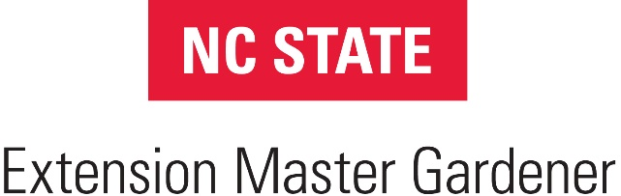

FOR IMMEDIATE RELEASE - Date
MEDIA CONTACT: YOUR NAME, PHONE NUMBER AND EMAIL ADDRESS
HEADLINE typed in caps and in bold
City, State, Date – Opening Paragraph (Who, What, When, Where, and Why) Begin your press release with a two sentence paragraph that provides a quick overview of the news and why it is important. It should read easily and make your news sound exciting to a general audience.

Next, provide some background information on the project. Make sure to write your release in terms that the general public will understand. Do not use jargon. Provide definitions for terms readers might not know.
Your text should explain the purpose, target audience, and benefits of your program, and intrigue the reader to visit your website, contact you for more information, recommend your program to a friend, or support your efforts.
The remainder of text should include any additional relevant information about your project or program. Include benefits, why your project/program is unique. Also include quotes from Master Gardener volunteers, staff members, industry experts or satisfied customers.
ABOUT North Carolina Extension Master Gardener Volunteers
Master Gardener volunteers support the mission of North Carolina Cooperative Extension by educating residents about safe, effective and sustainable gardening practices that grow healthy people, gardens, landscapes, and communities. Their vision is a healthier world through environmental stewardship.

The final short paragraph should be a brief description of your County Cooperative Extension Center and the programs and services it provides.

(Restate Contact information after your last paragraph):
If you would like more information about this topic or to schedule an interview with ________, please call ___________ at __XXX-XXX-XXXX____ or email ________ at _____@ncsu.edu
# # #
(Note: The three #’s mark the end of the press release)
When sending your press release to the media, send it as an email message with no attachments.

